National Weather APIs

In this project, we study the differences between the Weather.gov API and OpenWeatherMAP API. We will be utilizing the various functions within each respective API to create our own. The goal is for users to be able to enter in an airport’s IATA name and obtain the weather graph for the following location at a specific time period. The final API will be available for users to use for their own applications.

The National Weather Service (NWS) API allows develops to access the various weather information that is displayed on its website. This include access to critical forecasts, alerts, and observation along with other weather information. The information given typically based on a JSON data structure. However, there are other formats that is possible by the API. The following formats are formats available to the user to configure: GeoJSON, JSON-LD, DWML, OXML, CAP, and ATOM. The way to query temperature ranges for the day using the API to first provide a latitude and longitude to the API. For ex: <https://api.weather.gov/points/39.7456,-97.0892>. After calling the API, endpoint data is provided. The important field to notice is “gridX” and “gridY”. The figure below shows where that information is located at.

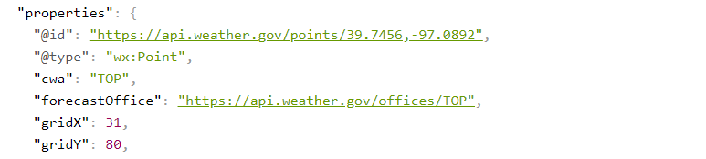

The grid location will pull temperature information from an office location. Passing the TOP gridpoint location to the API will provide the relevant data temperatures for that day. This call would be <https://api.weather.gov/gridpoints/TOP/31,80/forecast/hourly>. Under “properties” and “forecastHourly” will also give the correct URL to the hourly forecast. Temperature is then given per hour. The figure below is a snippet of how the data fields in JSON format are returned from the API.

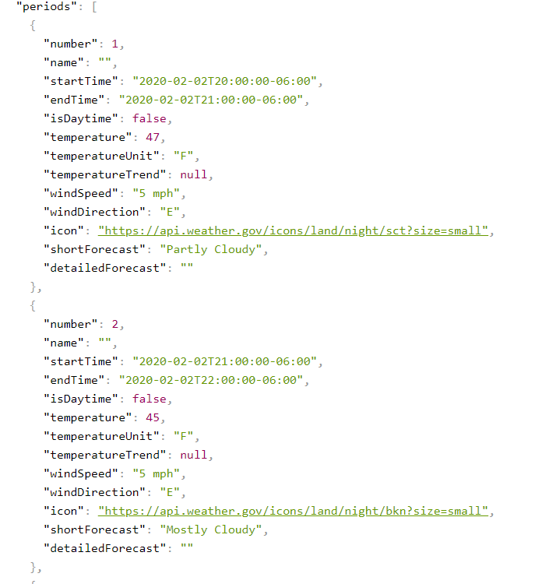

The OpenWeather API calls are very similar to the National Weather Service API. An example of a current weather of the day would be [api.openweathermap.org/data/2.5/weather?lat=35&lon=139](http://samples.openweathermap.org/data/2.5/weather?lat=35&lon=139&appid=b6907d289e10d714a6e88b30761fae22) given latitude and longitude data. The following is a snippet of the response of the API call.

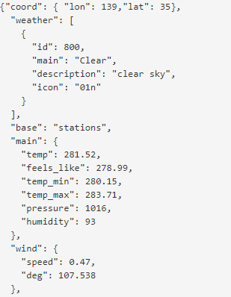

Immediately, OpenWeather’s API calls and responses compared to the NWS implementation are easier to digest. Information is group in a way that is logically intuitive compared to the NWS implementation. The output format is also in a JSON format. Like the NWS, the data is available in different output formats such as XML or HTML. There is a limit about 60 calls per minute. Also, an API key is required for using the OpenWeather API. The free account provides weather information for the current day and 5-day weather information with 3-hour increments.

In our API, we will be searching through a CSV file for the airport keyword. After valid keyword has been applied, hourly temperature will be given for the current day. This will be in JSON format for consumption. The interface will be a simple command-line interface that responds back if an invalid airport code was entered. The temperature data would then be plotted, and a window will pop up for the user to view. The following figure is the plot of temperature over a 24-hour period. The API will return -1 if an error has occurred.

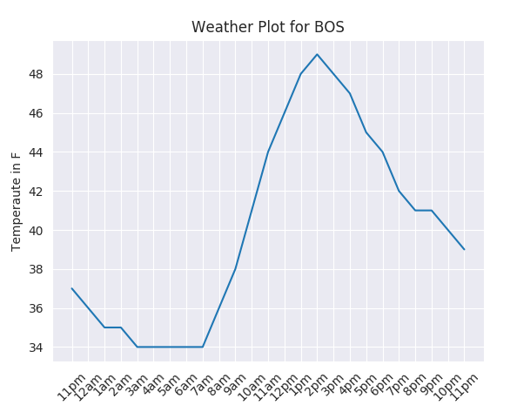

Overall, the APIs both provide similar output format. However, OpenWeather’s API provides a more user-friendly output that can be consumed by the user. The National weather service’s API is completely free, has two calls needed to grab temperature information but does not have many if not any limitations.